**Laws of the Game – Modified**

8 and Under (7U/8U)

Law 1 – The Field of Play

**MINI FIELD**

Dimensions: The field of play must be rectangular. The length of the touchline must be greater than the length of the goal line.

Length: minimum 25 yards maximum 40 yards

Width: minimum 20 yards maximum 30 yards

Field Markings: Distinctive lines not more than (5) inches wide. The field of play is divided into two halves by a halfway line. The center mark is indicated at the midpoint of the halfway line.

Optional: A circle with a radius of five (5) yards should be marked around the center mark.

The Goal Area: None.

Optional: Two lines are drawn at right angles to the goal line four (4) yards from the inside of each goalpost. These lines extend into the field of play for a distance of five (5) yards and are joined by a line drawn parallel with the goal line.

The Penalty Area: None.

Flagposts: Corner flags are optional.

The Corner Arc: None.

Goals: Goals must be placed on the center of each goal line. They consist of two upright posts equidistant from the corners and joined at the top by a horizontal crossbar. The recommended distance between the posts is six (6) feet and the distance from the lower edge of the crossbar to the ground is four (4) feet. Goals for this age group may be smaller.

Safety: Goals must be anchored securely to the ground. Portable goals may only be used if they satisfy this requirement.

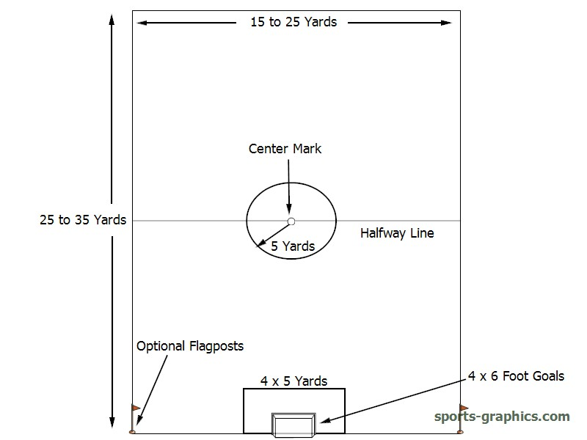

Law 2 – The Ball

Size three (3). The ball will need to be FIFA Quality.

Optional: use a lightweight size four (4) ball. A lightweight version reduces the weight of a size 4 soccer ball while still staying within the standards set by U. S. Soccer. Physical benefits of a lightweight ball include less stress on joints at the moment of impact and young players can make long passes, hard shots and block attempts by opponents.

Law 3 – The Number of Players

A match is played by two teams, each consisting of not more than four (4) players. There are NO goalkeepers.

Substitutions: At any stoppage of play and unlimited.

A player who is suspected to have a head injury leaves the field of play for additional evaluation, a substitution can be made in that moment.

Playing time: Each player SHALL play a minimum of 50% of the total playing time. It is the coach’s responsibility to enforce this rule. Teams and matches may be coed.

The maximum team roster size is eight (8).

Law 4 – The Players Equipment

Conform to the FIFA Laws of the Game. Non-uniform clothing is allowed based on weather conditions, but uniforms must distinguish teams. Shinguards are MANDATORY for both practices and games, and must be covered entirely by socks. If needed, teams can be distinguished by scrimmage vests.

Safety: A player must not use equipment or wear anything that is dangerous to himself or another player (including any kind of jewelry; with the exception of a medical alert bracelet).

Law 5 – The Referee

There is no need for fully qualified referees to manage 8 and Under games. One or both of the coaches should officiate/manage the game, while using best judgement of when to take advantage of teaching opportunities. Basic fouls and boundaries should be respected. All infringements should be briefly explained to the players.

Law 6 – The Other Match Officials

None.

Law 7 – The Duration of the Match

The match shall be divided into four (4) periods of not more than 10 minutes, based on the energy and motivation of the players. The length of the match should be determined before the match starts by both coaches. There shall be a maximum of a five (5) minute break between each period. The four periods do not have to be of equal duration.

Law 8 – The Start and Restart of Play

Conform to the FIFA Laws of the Game, with the exception that the defending team is at least five (5) yards from the ball until it is in play. Remember, let them play and do not interfere for technicalities.

Optional for 6U and younger: IYSA recommends using the “new ball” system in which all restarts come from the coaches on the field acting as referees. See the Developmental Philosophies section for more details.

Law 9 – The Ball In and Out of Play

Conform to the FIFA Laws of the Game.

Law 10 – The Method of Scoring

Conform to the FIFA Laws of the Game.

Law 11 – Offside

None.

Law 12 – Fouls and Misconduct

Conform to the FIFA Laws of the Game with the exception that all fouls shall result in an indirect free kick.

When a player deliberately heads the ball in a game, an indirect free kick should be awarded to the opposing team from the spot of the offense. If the deliberate header occurs within the goal area [if one is being used], the indirect free kick should be taken on the goal area line parallel to the goal line at the point nearest to where the infringement occurred.

The game official must explain ALL infringements to the offending player. No cards shown for misconduct.

N.B.: A hand ball infraction occurs when a player handles the ball deliberately. The “hand” includes the entire arm up to the top of the shoulder. Instinctive, self-protective reactions are not penalized at this young age. Accidental contact (ball striking hand or arm) is not an offense and should not be penalized.

Law 13 – Free Kicks

Conform to the FIFA Laws of the Game with the exception that all free kicks are indirect and all opponents are to be at least five (5) yards from the ball until it is kicked. Deliberate heading is not allowed in 4 vs. 4 games.

Law 14 – The Penalty Kick

None.

Law 15 – The Throw-In

Conform to the FIFA Laws of the Game.

Optional: the throw-in may be replaced with the pass-in; otherwise conform to the FIFA Laws of the Game. Opposing players are to be at least two (2) yards from the ball until it is kicked. This option is strongly recommended by US Youth Soccer.

Optional for 6U and younger: IYSA recommends using the “new ball” system in which all restarts come from the coaches on the field acting as referees. See the Developmental Philosophies section for more details.

Law 16 – The Goal Kick

The goal kick shall be taken anywhere along the goal line within five (5) yards of the goal. Opposing players must drop off five (5) yards from the ball until the ball is kicked.

Optional: Opposing players must drop behind the half line.

Optional: If the goal area is marked on the field of play then the goal kick shall be taken there.

Optional for 6U and younger: IYSA recommends using the “new ball” system in which all restarts come from the coaches on the field acting as referees. See the Developmental Philosophies section for more details.

Law 17 – The Corner Kick

Conform to the FIFA Laws of the Game with the exception that opponents remain at least five (5) yards from the ball until it is kicked.

Optional for 6U and younger: IYSA recommends using the “new ball” system in which all restarts come from the coaches on the field acting as referees. See the Developmental Philosophies section for more details.

Head Injuries

Per U.S. Soccer’s Concussion Initiative, if a player is suspected to have a head injury the referee* is instructed to stop play allow for treatment/evaluation as needed. If the player leaves field of play for additional evaluation, a substitution can be made in that moment. The player with the suspected head injury may not return to game unless a Health Care Professional (HCP) or Certified Athletic Trainer (ATC) has cleared the player. Any coach or parent insisting on returning the player to game without approved clearance will result in the referee* ending the game.

*Since there is no referee in 4 vs. 4, this responsibility falls to the coaches and parents involved.

The Youth Academy philosophy emphasizes player development over team development and focuses on the technical development of each child without the pressures of short-term match outcome. This club-based format is in the best interest of both the short-term and long-term development of the children. In most instances, the youth academy format does not have set teams. Instead, the players all register with the club, but not a specific team. US Youth Soccer supports this approach for the 8 and Under age group.

Developmental Philosophies and Best Practice Recommendations

* The “New Ball” system may be used for 6U and under, but the rules above should be followed at 8U. “New Ball” utilizes the coaches of both teams as “referees,” but both coaches will carry soccer balls with them on the field. When the ball goes out of play, the nearest coach puts a ball down and calls “new ball!” Coaches should work together to give opportunities of appropriate success and challenge to players on both teams.
* Coaches should have the age appropriate license issued by U.S. Soccer
* Formal games are not needed so playing with and against teammates at the end of each training session (1-2 per week) should be sufficient, but formal games are allowed.
* Formal rosters and teams are not needed so having a flexible and fluid approach to training and playing is recommended, but formal rosters/team are allowed.
* With 4 players on the field, having 6 players on each “team” when the “game” is played helps maximize participation and engagement.
* Results and standings should not be recorded.
* Travel should be limited as much as possible.
* Players should not be participating in events (tournaments, showcases, festivals, etc.).
* Remember that safety and fun are the top priorities so make adjustments as needed to ensure both are being promoted.
* Athletes should be encouraged to participate in various sports.
* Players should get regular chances to play in all positions and roles.
* Focus for training and instruction should revolve around technique, attitude, balance, and speed.
* Player first, club second, team third.
* Person first, athlete second, player third.